ACTIVITY-APPLICATION BUILDING WITH KNIME (ANY 2)

Name : K.YOGANAND
Reg no,: 192525173
Course : CSA1606 - DATA WAREHOUSING AND DATA MINING

ACTIVITY 1: SALES ANALYSIS DASHBOARD PROBLEM STATEMENT
A retail company wants to analyze its monthly sales.

TASK:
Build a KNIME workflow that:
- Imports a sales dataset.
- Cleans missing values.
- Calculates monthly sales.
- Identifies the top 10 products.
- Creates bar and line charts.
- Generates a summary report.

Expected Outcome:
An interactive sales analysis workflow.
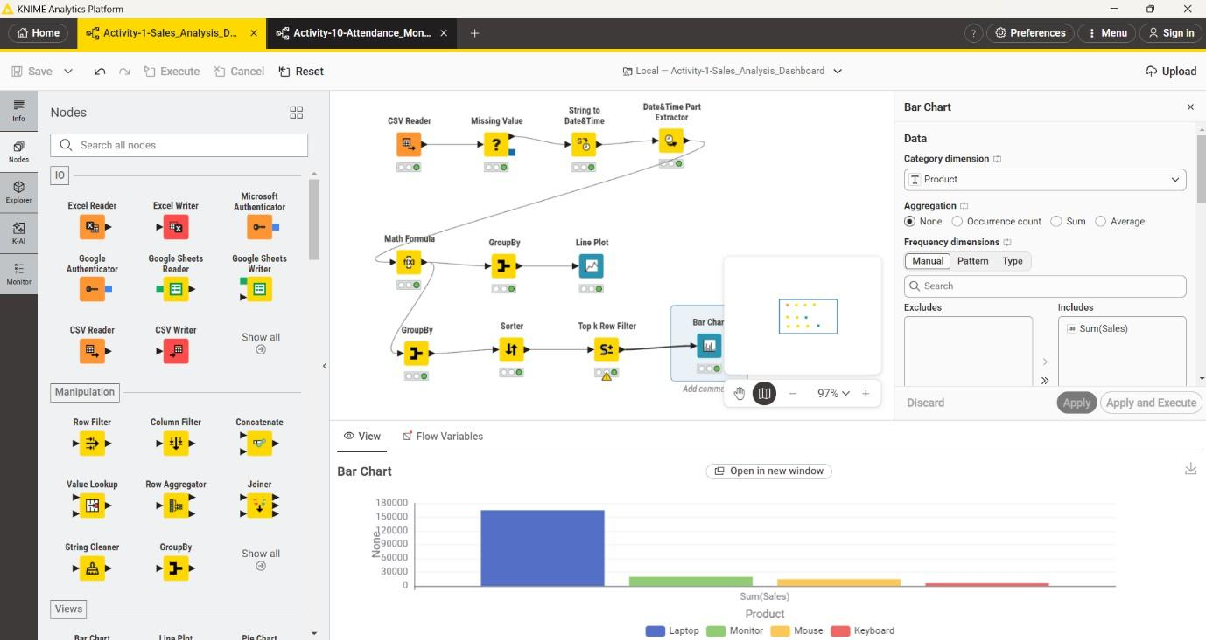

ACTIVITY 10: ATTENDANCE MONITORING SYSTEM PROBLEM STATEMENT:
Analyze attendance records to identify students with low attendance.

Task:
Build a workflow that:
- Imports attendance data.
- Calculates attendance percentages.
- Flags students below the attendance threshold.
- Generates a report.

